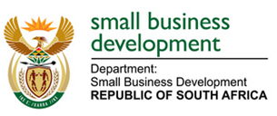
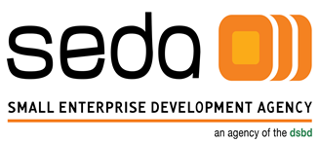

Press Release

Date: 25 October 2018
To: Media houses & journalists

Seda, DESTEA and FDC bring significant development to Free State entrepreneurs and their businesses

The Small Enterprise Development Agency under the Department of Small Business Development with its partners in the Free State – the Department of Economic, Small Business Development, Tourism and Environmental Affairs and Free State Development Corporation – are bringing about significant changes to many small enterprises in the Free State province. Despite the economic challenges around growth and unemployment, SMMEs remain South Africa’s hope in reversing the country’s high unemployment and poverty rates.
DESTEA, FDC and Seda have provided support services to SMMEs in the Free State, enabling increased growth and sustainability of these businesses. Seda has provided support to 1 579 SMMEs during the 2017/18 financial year through its five branches located in the province of which 97% were black-owned, 45% were women-owned and 51% were youth-owned. DESTEA also provided various financial and non-financial support services to 78 SMMEs in the Free State for the current financial year.
Among the SMMEs supported are Unexpected Clothing; a fashion design and sneaker manufacturing business; KN Studio which focuses on animation and graphics; Pheehello Funeral Parlour; City Travellers which provides hospitality and travel services to corporate and leisure clients; Diesel Country; Havillah Beauty which provides beauty services and has a training academy; and Cote a Cote which deals with ceramic manufacturing.
Pheehello Funeral Parlour received loan funding from FDC to acquire operating premises in Botshabelo, equipment, material and working capital. The business also received additional funding to purchase a hearse. The business has since been able to pay back the entire loan in full to FDC. Seda assisted with branding and the facilitation of a business plan which would enable the business to acquire additional funding in the future.
Havillah Beauty was able to secure R600 000 worth of manufacturing equipment through Seda’s Technology Transfer Fund. Following this and other interventions, the business has experience exponential growth in turnover and has doubled its staff complement.
Diesel Country was assisted by DESTEA with access to markets which was facilitated through acquiring exhibition space at the Manufacturing Indaba. This resulted in improved sales with various clients and gaining a potential investor. The businesses’ monthly turnover has improved significantly.
The improvement, growth and sustainability of SMMEs across the country can only be achieved through collaborative efforts between government agencies with aligned mandates and objectives, as well as joint efforts between government and the private sector. The growth in the number of SMMEs in South Africa annually gives hope that as a country we are well on our way to creating generations of entrepreneurs and people who create employment and contribute to inclusive economic growth.

END

Enquiries:
Boy Ndala (Seda)
Cell: 0833404603
Email: bndala@seda.org.za

Or

Festy Mfazwe (DESTEA)
Cell: 0833408502
nyamatef@destea.gov.za

